SUCKLEY PARISH COUNCIL
COMMUNITY NEWSLETTER – SUMMER 2003

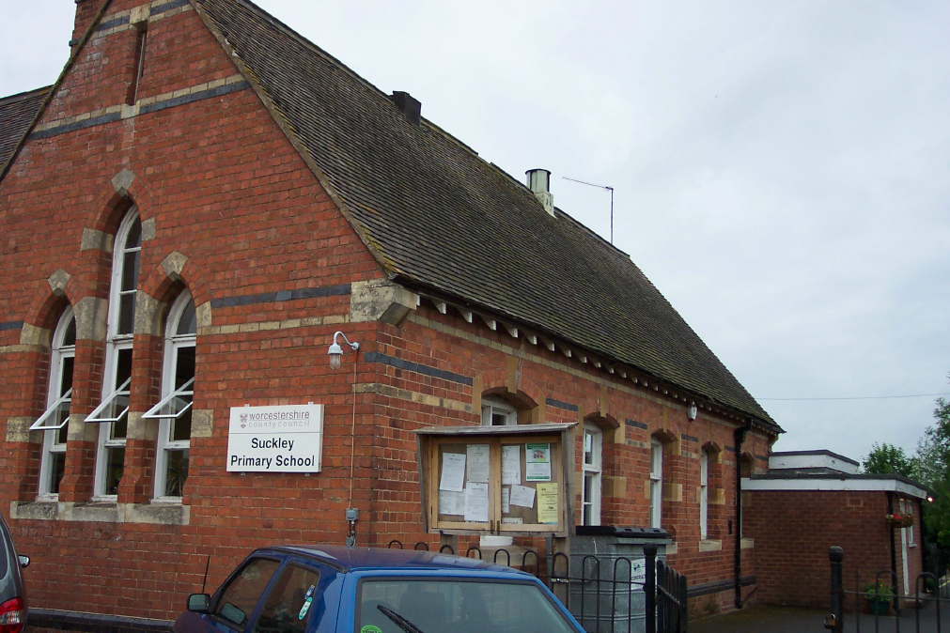  SUCKLEY SCHOOL  Suckley School have received a letter from David Milliband, Minister of State for School Standards, informing them that they have succeeded in gaining a School Achievement Award. This has been presented as a consequence of achieving better results in the School Year 2001/2002 than other schools in similar circumstances.  Credit is due to the Headmistress Miss Sara James, the teachers, governors, the parents, and the pupils, for achieving this on behalf of the local school. |  | Pat Perks – Parish Clerk
 |  | Tel. No 01531 640438
SUCKLEY IS FAMOUS!!
Suckley recently featured as ‘the loveliest village of the plain’ in ‘Limited Edition’, a Worcestershire magazine. The article featured The Suckley History Society, the Playgroup, the Suckley Harriers, plus local landmarks such as The White House. Suckley was described a ’one of the prettiest villages in the Teme Valley’ Who are we to disagree!

ANY SUGGESTIONS?
Suckley has a website (www.suckley.net) with information on the village activities.

The Parish Council is keen to hear suggestions from the parishioners of what can be done to improve village life in Suckley. For August only, a ‘Suggestions Box’ has been set up, so please send any suggestions for the Parish Council to suggestions@suckley.net Please mark your e-mail for the person responsible for that area of the Council’s remit (See Below). All suggestions welcome!

GOOD NEWS!
Men aged 60 and over are now eligible to apply for a bus pass and forms for this can be obtained from the Post Office.

VILLAGE HALL
Please note that all bookings for events at the Village Hall should now be made through Pamela Ashford on 884754.
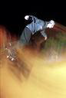  SKATE PARKS –  They’re open!  The skate parks in Alfrick & Suckley are now open and are being regularly used. | Parents in Suckley are asked to encourage their children to use the designated skate parks rather than public car parking areas where possible.  Also if you could please park cars in the area provided rather than driving over to the skate parks. Thank you. | YOUR COUNCILLORS – What do they do?
The Parish Council as a whole are responsible for community issues, but certain Councillors take major responsibility for key areas. The Councillors, and their responsibilities are:-

Walter Huband (884379) – Chairman; Suckley Charities
Brian Harvey (884201) – Vice Chair; Police
Pearl Griffiths (884354) – Planning; Playing Fields
Marnie Caine (884229) – History Society & Records
John Green (884412) – Playing Fields
Robin Hill (884752) – Suckley School; The Quarry
Liz Devenish (884787) – Local Housing; Village Directory
Richard Barnes (884271) – AONB; Newsletter; Health
Paul Beaumont (884550) – Youth Group

Please note that MHDC are responsible for all planning and enforcement issues, and the Parish Council review planning applications after submission.
SUCKLEY HISTORY SOCIETY –  It’s a true fact!  The parish magazine of April 1893 reports, "It is intended to give a concert in Suckley schoolroom on 16 May on behalf of the fund for providing instruments for the Brass Band which has lately been started in the parish." The instruments were subsequently sold – can anyone remember when?  For information on Suckley History Society please contact Richard Harward on 884611 |  | Dates for your diary  Aug 3rd All age service – Suckley Church 11.00am  Aug 9th Clive John live at The Nelson  Sept 2nd Suckley School re-opens  Sept 9th Parish Council Meeting  Sept 27th Paul Jolley live at The Nelson  Oct 23rd Suckley History Society – Open meeting –  Talk on the saltways of Droitwich - 7.30pm  See Village Directory for venue details.

